Name : Ansari M.Saeem M.Saleem
Uid : 2019430001
Subject : AAC
Expt no : 3
Aim : Write a program to implement and Analysis Matrix Chain Multiplication & Cutting Edge Problem

Aim:
Write a program to implement and Analysis Matrix Chain Multiplication & Cutting Rod Problem.
Objectives:
- Finding how the matrices are multiplied together with minimize scalar multiplication operation.
- Finding the cost to multiply matrices.
- Finding shortest path from source node to every other node.
Methodology:
- Matrix Chain Multiplication :
The matrix-chain multiplication problem can be stated as follows: given a chain A1 , A2 , … ,An of n matrices, where for i = 1, 2, ..., n, matrix A i has dimension p i-1 × p i , fully parenthesize the product A1 A2 An in a way that minimizes the number of scalar multiplications.
Note that in the matrix-chain multiplication problem, we are not actually multiplying matrices. Our goal is only to determine an order for multiplying matrices that has the lowest cost.Equation to find minimum cost parenthesizing the matrix multiplication is :
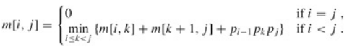

- Cutting Rod Problem :
Given a rod of length n and an array of prices that contains prices of all pieces of size smaller than n. Determine the maximum value obtainable by cutting up the rod and selling the pieces.

Time Complexity:
Matrix Chain Multiplication: O(n^3) where n is no of metrices.
Cutting Rod Problem: The first step in the algorithm is simple and runs in O(V) time because it needs to make a new edge to all vertices in the graph. The second step of the algorithm, Bellman-Ford, runs in O(VE) time, as does Bellman-Ford. The final step of the algorithm is Dijkstra's algorithm run on all Vvertices which is O(V2log(V)+VE).
Matrix Chain Multiplication :
Input:
A1 30 × 35
A2 35 × 15
A3 15 × 5
A4 5 × 10
A5 10 × 20
A6 20 × 25
Output:
Cost = 15125
Order = (A1(A2 A3))((A4 A5)A6)
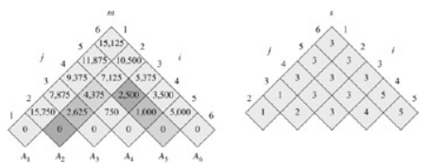

Implementation :
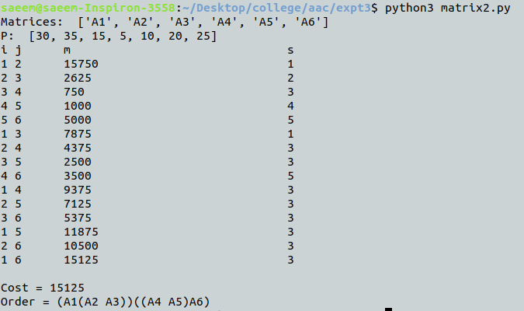

\

Cutting-Edge problem :
Conclusion:
Here we can conclude that Bellman-Ford works on negative edge weight which is the advantage of Dijkstra's algorithm. Johnson’s Algorithm is based on Bellman-Ford algorithm and Dijkstra's algorithm. Bellman-Ford required less time to find shortest path but on the other hand Johnson’s algorithm required more time as we increased the density of graph.

